**REPORT ON THE REMOBILIZATION SURVEY FOR THE KOFKRO PROJECT**

**Author: Francis Adu Amankwah**

**Organization: AFES – GHANA**

**13th November 2024**

**INTRODUCTION**

The youth represent the most vibrant part of the New Juaben South Municipality (NJSM), hence there is the need to mainstream the challenges they face in their communities that acts as barriers to their participation in youth governance. Again, as they hold the promise of the future, we must explore avenues to help them address these challenges and engage them meaningfully in the decision-making process. This survey seeks to ascertain

* The participation of the youth in governance
* The demographics and social status of the youth in Koforidua
* The challenges they face in their communities
* The interests of the youth
* The avenues for youth development.

The survey covers the New Juaben South district across 34 electoral areas on youth aged 15 – 35. For the remobilization, there was a particular focus on marginalised groups such as Persons with Disabilities (PWDs), Ghetto, Street and Zongo youth.

**METHODOLOGY**

**Survey Design**

The survey consisted of 45 unique questions under the thematic areas of demographics, contact information, employment status, interest and needs, and participation in governance.

**Sampling Technique**

To address our aim of reaching marginalised groups (especially in the case of PWDs), we used the snowballing technique. At the end of the survey, we had 2932 respondents, of whom about 5% were PWDs.

**Data Collection Process**

The data collection was carried out by 30 enumerators from the AFES – Ghana group over a two weeks period in October 2024. It was collected using an online questionnaire.

**Data Analysis**

We employed univariate and multivariate analysis to ascertain the distribution of variables of interest such as education status, employment status, gender, age, participation in election, challenges and interest of the youth.

**RESULTS AND DISCUSSIONS**

**Demographics**

In the analysis, we found that 37.2% of the respondents were within the age range of 21 – 25, 30.9% in 15 – 20, 21.7% between 26 – 30 and 10.2% in 31 – 35 with a gender distribution of 60.4% males and 39.6% females. About 9% of the respondents were married. We had that about 5% of the respondents had various disabilities. Regarding the educational background of the respondents, about 65% said they had attended school in the past, 30.8% are currently schooling whiles 3.8% had never attended school. Figure 1 shows the educational levels for the respondents who are currently schooling and those who attended in the past respectively.

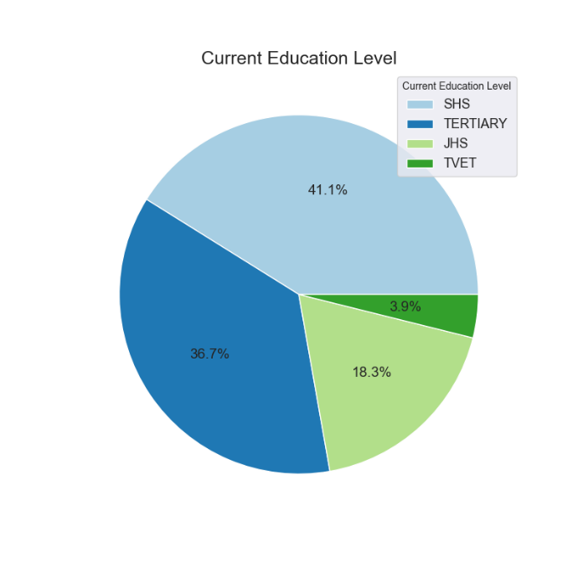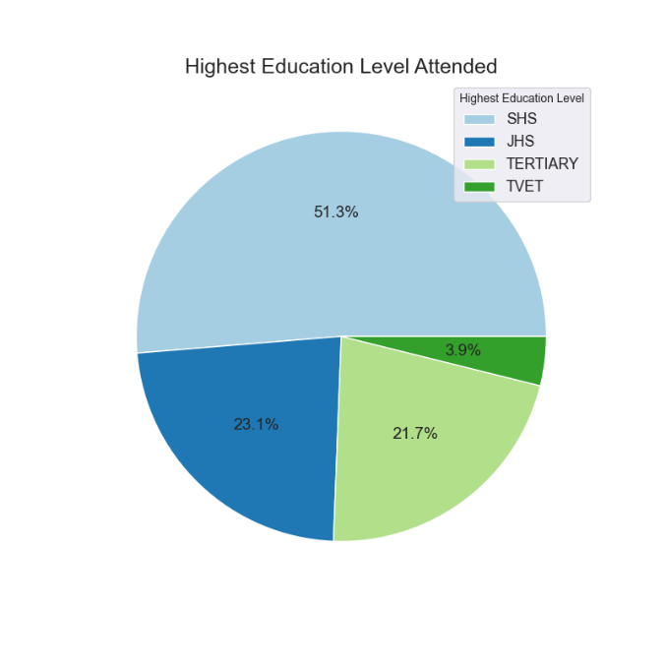

Figure 1: Respective educational level for respondents currently schooling and those who attended in the past

The distribution of the various types of disabilities the respondents had is shown in Figure 2. Of all persons with disabilities interviewed, the most dominant type of disability is physical disability followed by hearing impairment and visual impairment. As we can see from the graph, they are some individuals with more than one type of disability.

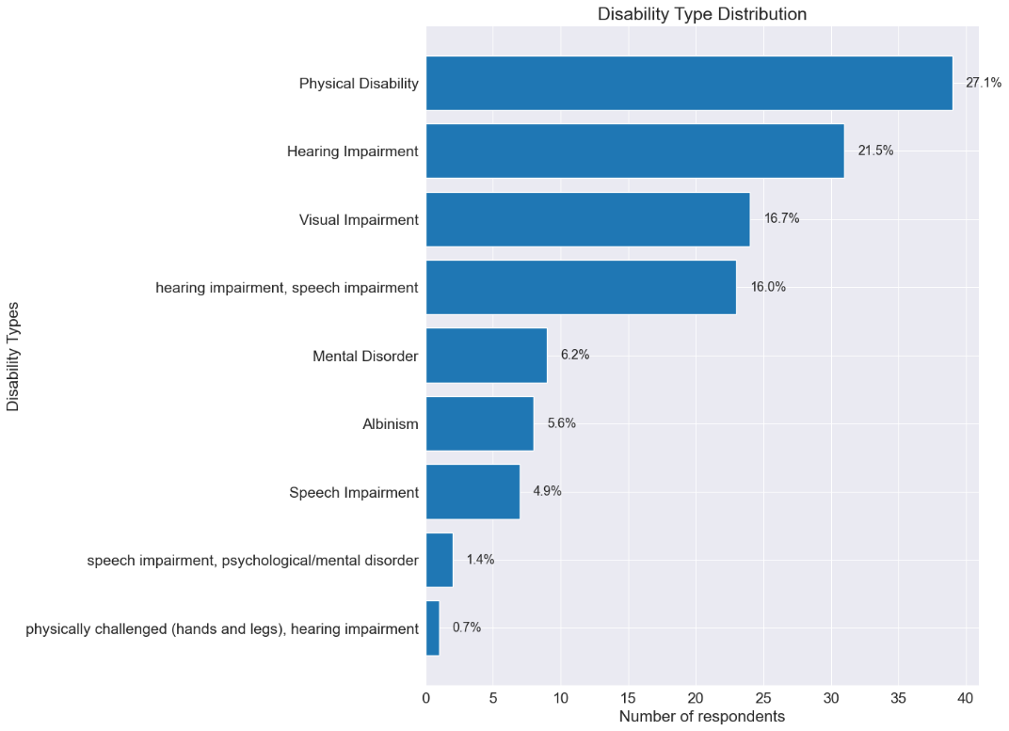

Figure 2: Types of disability

As mentioned earlier, the survey was conducted across all 34 electoral areas in NJSM. The distribution of the number of respondents in each electoral area is shown in Figure 3. As we can see, the *Nsukwaoso* electoral area appears to have the highest number of respondents.

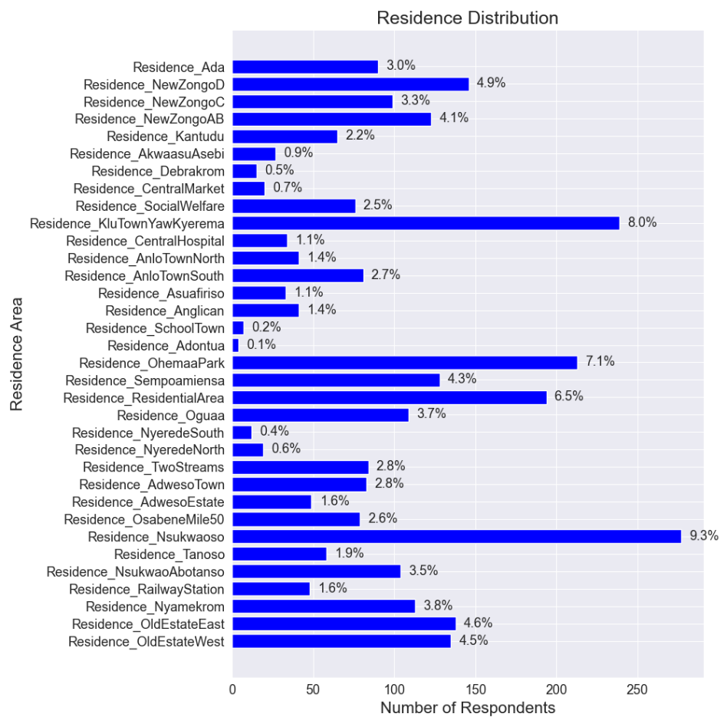

Figure 3: Percentage of respondents from each electoral area

To ascertain which respondents can be categorised as ghetto, street or Zongo youth, we made a distribution of the places they spend most of their time during the day and at night, which is shown in Figure 4.

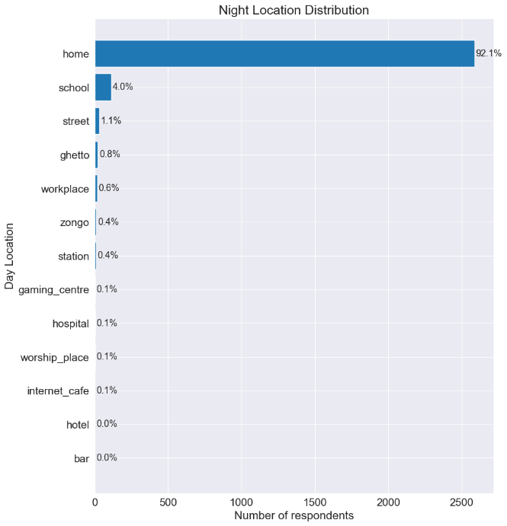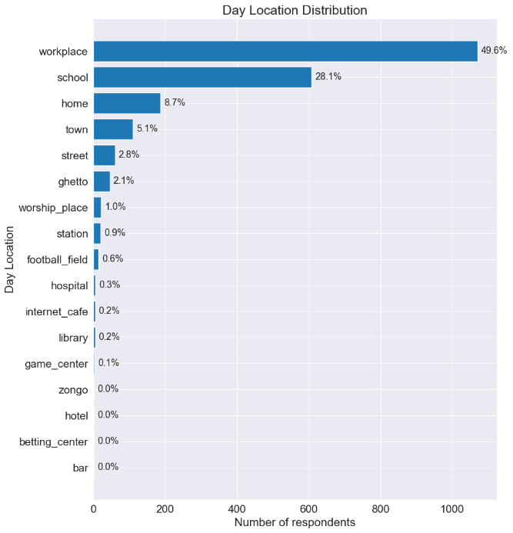

Figure 4: Location where most time is spent during the day and night

In the evenings, we have most of the respondents staying home (over 90%). To narrow it down to the marginalised groups we are interested in (street, ghetto and zongo youth), a special distribution was made separately for these locations.

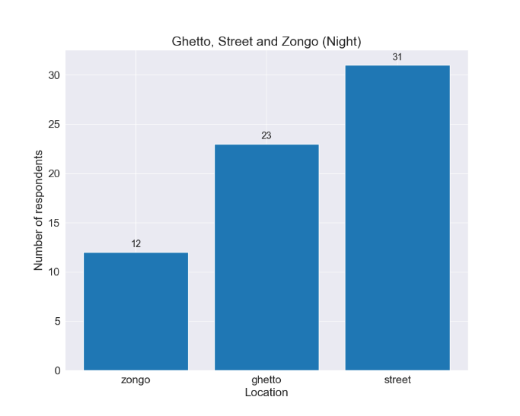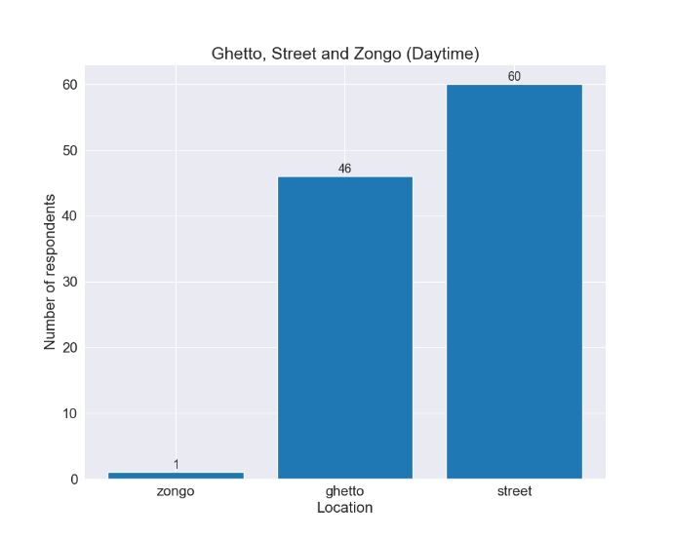

Figure 5: Distribution for respondents who spend most of their time in ghettos, zongo or on the street.

From Figure 5, we can see that we have more street youth than ghetto or zongo youth. Especially during the day, we have only one respondent who spends most of the time in Zongo.

**Employment Status**

Questions about the employment status of respondents helps to ascertain the social welfare and possibly hint on their wellbeing. Out of all the respondents, 60% were unemployed, 15.9% were employed and 24.2% were self-employed. This hints to the huge problem of unemployment facing the youth in the NJSM. Again, larger proportion of workers who are self-employed compared to those employed by others asserts to the entrepreneurial spirit of the youth. It stands to reason that provided with the resources and support, most of the youth might venture into entrepreneurship, thereby providing employments for themselves and others. Figure 6 gives a distribution of the various works the working proportion of the youth are engaged in. From Figure 6, it has been established that most of the youth are involved in sales and a significant number specialize in ventures where they offer services.

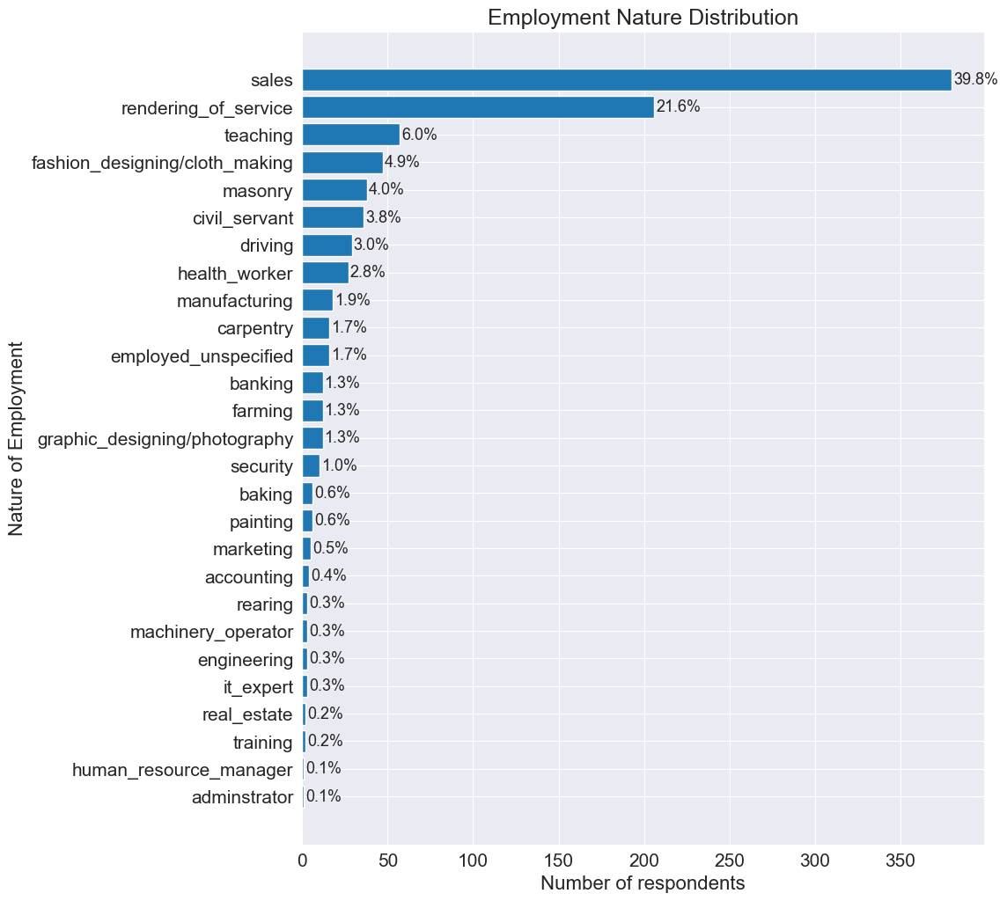

Figure : Nature of employment by the working population of the respondents.

**Access to Social Amenities**

About 90.5% of all respondents had access to basic social amenities. In the survey, the amenities considered were; water, electricity, hospitals, schools and toilet facilities. A significant proportion (about 7.6%) reported they do not have access to these social amenities. Figure 7 shows the percentage of respondents which had access to each of the amenities listed above.

We can establish that most of the residents in the NJSM have access to electricity compared to other amenities. Again, 89.2% of the respondents said they had the National Health Insurance Scheme (NHIS) card, which hinted on their access to healthcare. About 9.9% had no insurance card and 0.9% where no sure whether they had a health insurance card or not. This response could be associated with issues such as expired insurance cards.

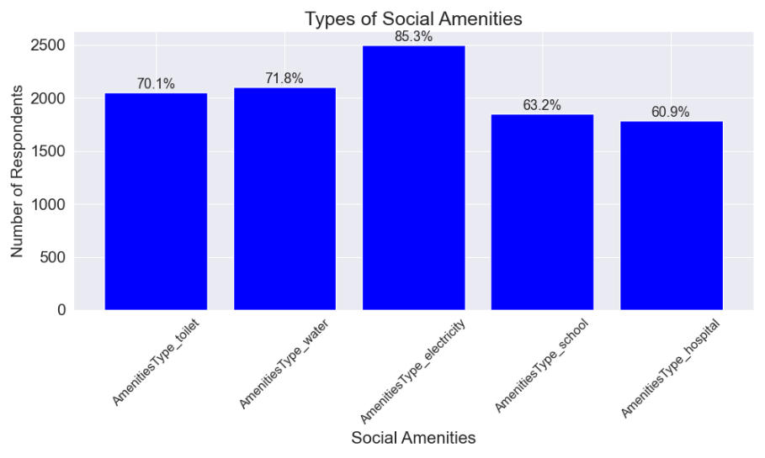

Figure : Access to basic social amenities

**Youth Participation in Governance and development**

Over 80% of the respondents had registered for the voter’s ID card, 19.5% did not possess the voter’s ID while about 0.3% were not sure whether they had the card or not. Interestingly, only 73.1% of those who had voter’s ID had voted before, 25.5% had never voted despite possessing voter’s ID cards. Perhaps individuals who just came off voting age maybe dominant in this category. To ascertain their willingness to participate in the upcoming general elections, we had 65.2% responding positively toward voting, an appreciable percentage of 20.5% had not yet decided whether they would vote or not, and about 14.3% vehemently said they will not be voting in the upcoming general elections. Most of the respondents had never participated in any town hall meeting before (80.5% to be exact) while only 17.3% had taken part in town hall meetings. It could be as a result of inadequate advertisement or broadcasting of town hall meetings early enough. Regarding youth participation in developmental projects, 72.1% reported that they had taken part in communal activities. The activities they usually partake in is shown in Figure 8.

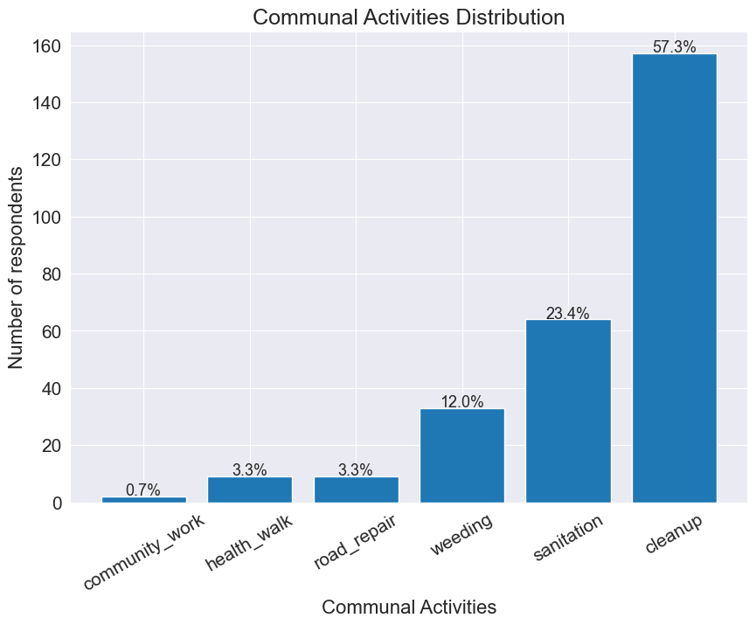

Figure : Communal Activities

Almost 70% of the respondents showed an interest in joining future youth activities. These activities may range from open discussions about governance to seminars and workshops organized for the youth. Despite considerable number of respondents showing interests, approximately 16% expressed no interest in taking part in such activities while 14% were not sure of their stance.

**Needs and Interests**

One of the most important reasons for conducting this survey was to inquire about the challenges the youth face in their various communities. Unanimously, all the electoral areas had considerable challenges with employment. Other pertinent challenges such as drug and alcohol abuse were noticeable although several respondents claimed this was directly caused by unemployment. A more elaborate presentation of the challenges is given in Figure 9. Despite some common challenges, each electoral area had their own unique challenges expressed by the respondents. Plots of the challenges faced by each electoral area can be found in the Appendix section of this report.

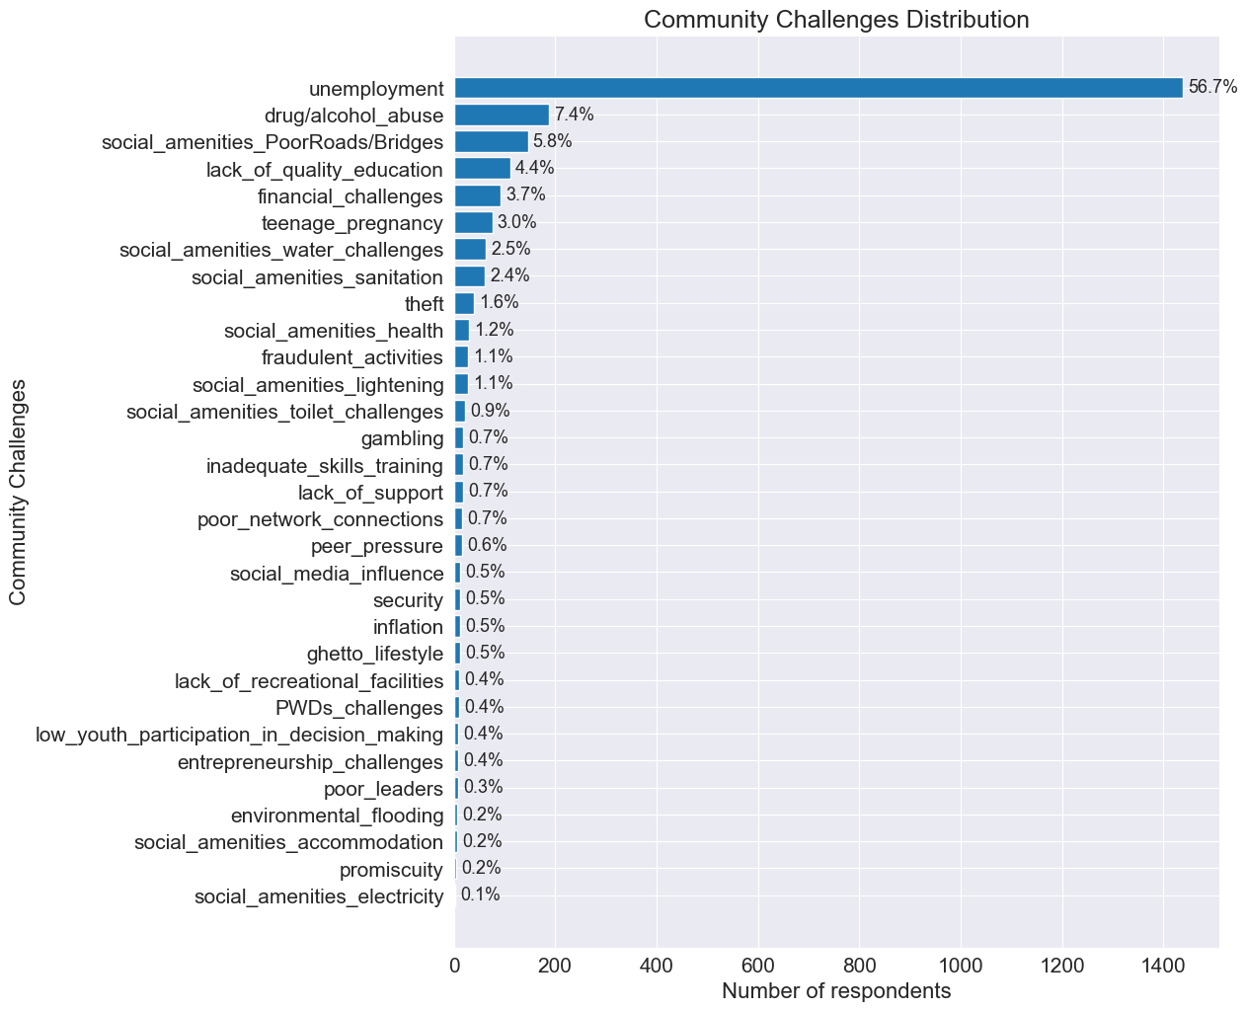

Figure : Challenges facing the youth.

Figure 10 throws more light into the interests of the youth in the NJSM. It is obvious from Figure 10 that most of the youth are interested in movies, games and sports. In the case of sports, since it also acts as a way of exercising and keeping the body fit, more attention is needed in this area. It might be of great importance to create more recreational facilities and promote more sporting activities. Also, given that movies take lead, creation of cinemas and other such ventures might go a long way to meet the interests of the youth.

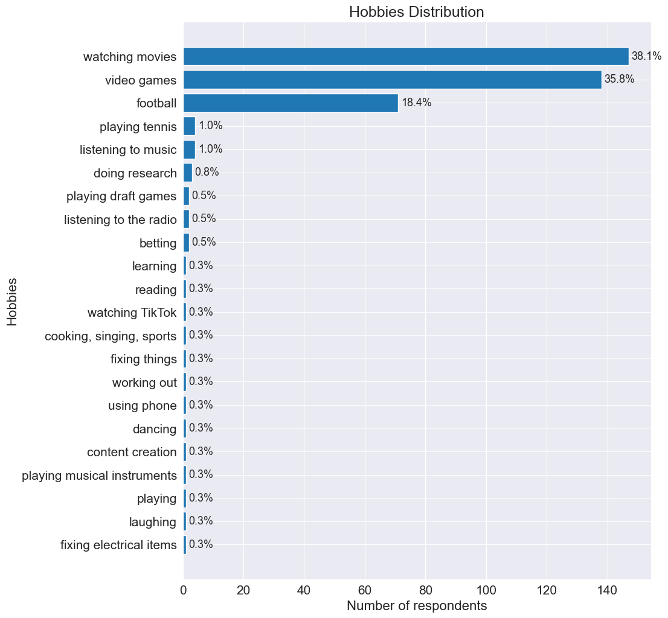

Figure : Hobbies and Interest

**CONCLUSION**

**APPENDIX**

